Character LCD Module

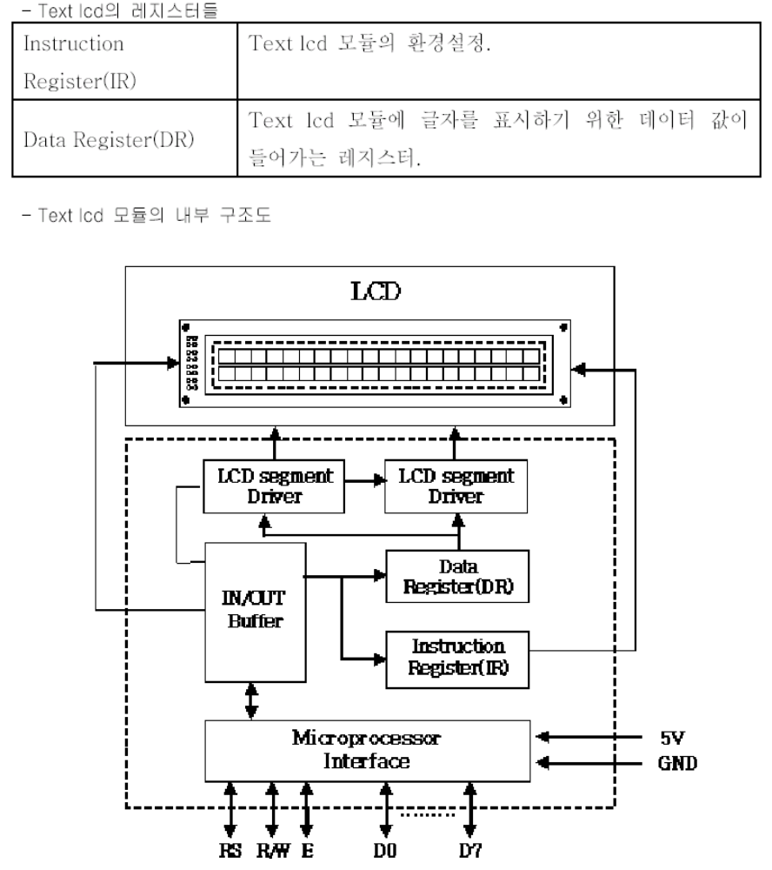

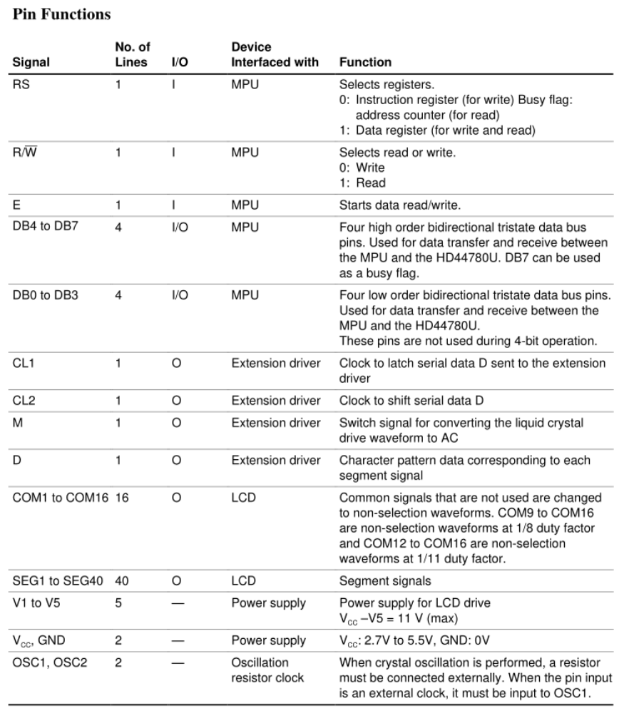

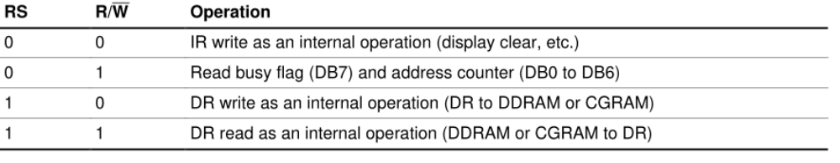
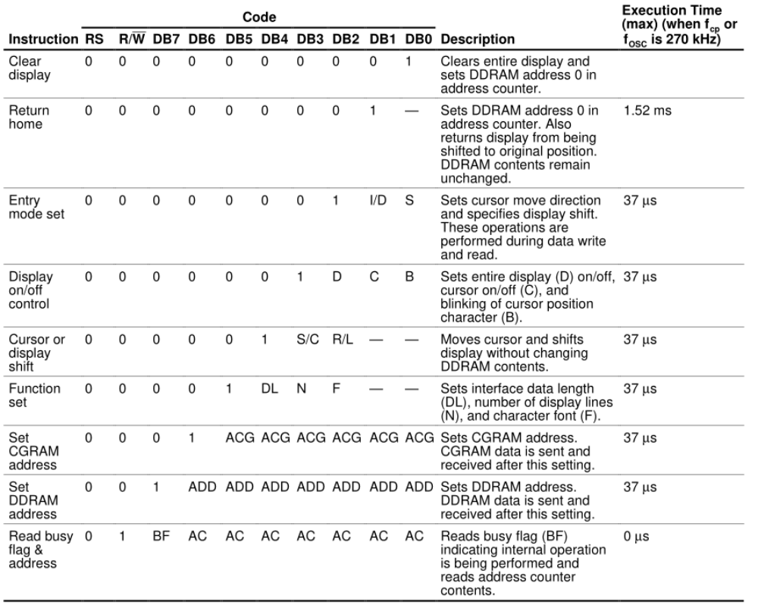

LCD_command(0x06); // entry mode set(increment, not shift)
I/D=1 (0: Decrement by 1, 1: Increment by 1)
S=0 (0: no shift)

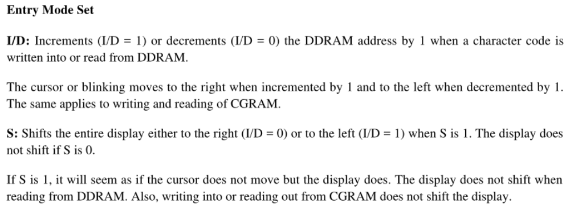

LCD_command(0x0C); // display control(display ON, cursor OFF)
D=1 (0: Display off, 1: Display on)
C=0 (0: Cursor off, 1: Cursor on)
B=0 (0: Blinking off, 1: Blinking on)

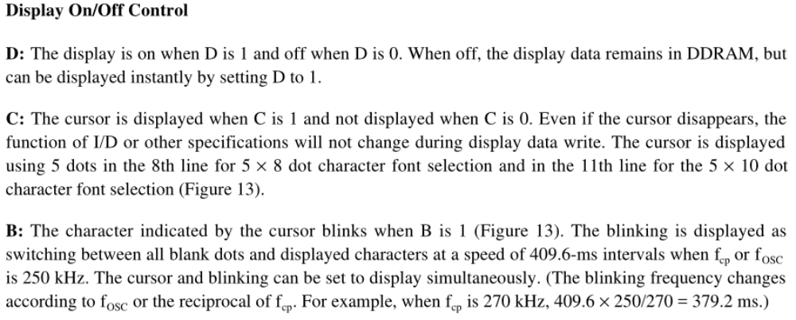

LCD_command(0x38); // function set(8 bit, 2 line, 5x7 dot)
DL=1 (1: 8-bit interface data)
N=1 (0: 1-line display, 1: 2-line display)
F=0 (0: 5x8 character font, 1: 5x10 character font)

